2-ton Pure Electric Washing & Sweeping Truck
一、Product Overview
HWL5020TXSBEV electric washing and sweeping vehicles is a new generation multi-function sanitation vehicles fully developed by our company. It is built on specialized heavy-duty electric class II chassis（Chassis Model：ZB1022BEVGDRJ0）Mounted on the chassis are sweeping, suction, water system, power system, SS tank body, and hydraulic system,it integrates the function of road sweeping vehicle and high pressure washing vehicles,it has multi-functions for road surface washing, sweeping,waste collection, curb and curb facade scrubbing, meanwhile, high-pressure water gun cleaning for road sign and billboard, its compact body design resolves the issue that small sweepers often lack road access and vehicle registration eligibility in domestic.The vehicles wide is 1.35 meter only, it features small compact design and excellent maneuverability, easily passing through road barricade. Water tank and garbage body are separated, while the water tank volume is 700L, which adopted rotational moulding integration technology, offering an elegant appearance,customized color, long service life, without corrosion problem associated with welded body.Sewage container capacity is 800it is equipped with hydraulic tipper device, the high-position uploading can connect with 660L garbage can or garbage compactor vehicle, which in avoid of secondary contamination , vehicle running speed up to 71km/h, improving transfer working efficiency, the vehicle air conditioner is installed for increased comfortable driving experience.
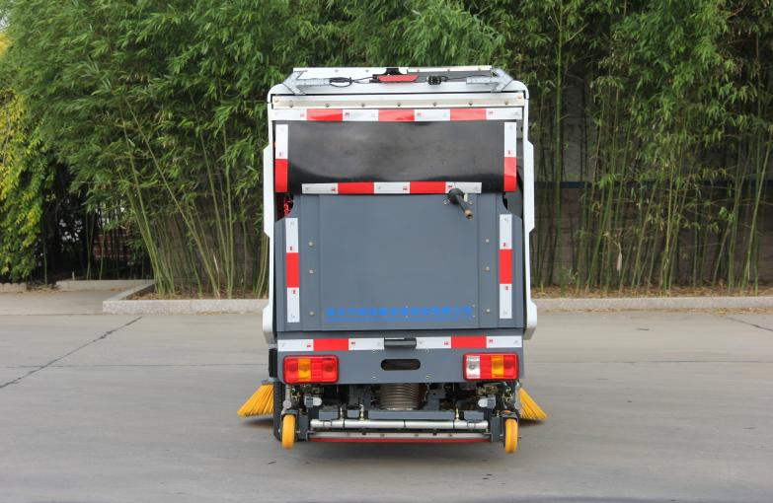
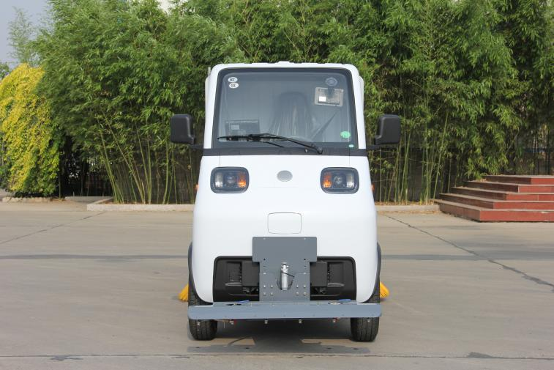
Front Rear

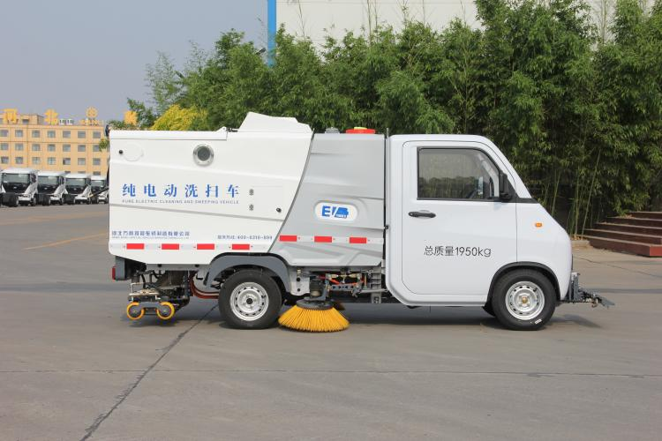
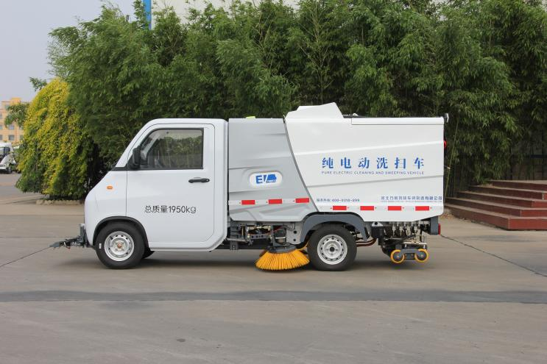
Left

Left Right
二、Function Overview
1.It can washing,sweeping and cleaning for road surface and road kerb, sidewalk, auxiliary road.
2.It can washing road sign, advertisement board(high pressure spray gun)
3.Standard tank body self-cleaning, one-click drainage function.
4.Optional for front fixed-point washing, front angle spray, front sprinkler frame, rear mist spray, maintenance pushcart,obstacle-crossing cleaning device.
三、Application Scope
It has widely application including urban & rural sanitation, municipal park, property cleaning, factory, schools, hospitals and etc.
四、Main Structure and Performance Character
1.Chassis
Chassis adopted the ZB1022BEVGDRJ0 electric class II chassis, which has standard air conditioner, multi-functional steering wheel and low-speed cruise control. It utilize CAN network communication, supporting expanded system for remote fault diagnose monitoring system, battery monitoring system, and error code automatic storage system. Tailored to high voltage characters,a high voltage interlocking system, high voltage equipment two stage insulation system,and fault diagnose and processing system has been developed to ensure vehicle safety.
Drive System: It utilize a lithiumphosphate ironbattery power storage system pluselectric drive axle powertrain, driving motor utilize TZ170XZD3 permanent magnet synchronous motors (PMSM), electric motor’s maximum torque is 105Nm,maximum rotational speed is 9000rpm. Electric drive axle output enhances system stability and reliability, driving power in instant response, system is reliable as well as easy to repair, it has been widely deployed in truck and commercial vehicles industry. Controller make to electric motor according to overall vehicle condition, driving motor protective class is IP67
Chassis battery, it utilize original battery pack(cell and BMS) made by Hefei Gotion High-tech Power Energy Co., Ltd, withenergy management system featuring automatic test and passive balancing,to make battery consistency, better power performance, high efficiency, safety and reliability.The Lithium iron phosphate battery is 52Ah cell, offering long cycle life, high safety, excellence heat dissipation of cell, lower internal resistance, and better consistency performance.
Chassis electric control utilize advanced vehicle controller hardware, software utilize smart energy management system,which makes electric motor operating points into.higefficiency range as much as possible, meanwhile braking energy is recycled, overall economic efficiency is improved, and the controller protection rating is IP69
2.Sweeping system
The sweeping system utilize “central-mounted double vertical brooms+ rear extra wide suction nozzle with built-in high pressure nozzle inside+ rear high pressure spray bar”

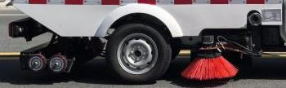
1 ）Suction nozzle has a total width of 1000mm,suction width can be 900mm, which almost matching the vehicle width, with maximum work capacity 20000 Ⅳ/h, it delivers higher suction efficiency, achieving 95% cleanliness rate（gravel density 150g/ Ⅳ)on cements road surface.
2）It utilize conventional dual-purpose sweeping discs with both washing and sweeping, feature collision avoidance functionality. During operation, when the discs encounter an obstacle ahead, they retract inward to clear the object and automatically return to the normal working position afterward.
3）The high-pressure spray bar is fixed with pipe clamps, not easy loosen. The suction nozzle offers limit range floatingto follow ground contours, ensuring easy maintenance and excellent adaptability to various road conditions.
4）The suction duct has a diameter of 180 mm,capable of absorption large-particle debris without risk of clogging.
3.High pressure water system
High pressure water system mainly consist of water filters, high pressure water pump,electronically controlled water distribution valve, hand-held spray gun, and pipe.It has function road surface flushing, tank body self-cleaning, and hand spray gun washing. Key features:
1 ）High pressure water system utilize integrated electronically controlled high pressure ball valve assembly, has character of eco-friendly and energy saving
2）High pressure water pump utilizing famous brand triplex plunger pump with rated flow of 30L/min/ 1450rpm, rated pressure 12MPa, cleanliness rate over 95%, high efficiency and reliability.
3）High pressure water system is protected by unloading valve, which relieves pressure when operation stops, safeguarding the entire system. System adopted pressure gauge monitors water pressure to prevent over pressure and associated hazards.
4）A filter is installed ahead of water inlet on the high pressure water pump,to prevent waterborne impurities entry to the pump,extended water pump life service
5）Pipeline’s layout is reasonable without interference, with character of overall beautiful, easy to inspect and replace.Conical sealing is used to minimum leakage risks. Joint parts using famous brand for stable and reliable quality.
4.Broom dust control system
Broom dust control system consist of disphragm pump, nozzle and piping.It control dust by spraying water mist through nozzle positioned in front of the boom, generally it used in sweeping mode, effectively reduced airborne dust during operation, improves working efficiency.
5.Tank body
The body adopt split structure of “waste container plus water tank” , materials using SS304 with good corrosion resistance, side panel and bottom plate of body use flat plate design with smooth internal surface, high strength and excellent impact resistance against waterforce.
1 ）The water tank is fitted with a low-level sensor and the waste container with a high-level sensor.there is voice alarm installed in the cab,as reminder of water level,so operator can know water level status inside the tank.
2）There is filter screen inside the waste container, which can effectively prevent leaves,plastics and other lightweight debris, so no need worker cleaning inside the tank any more.
3）The rear door of the waste container is equipped with a circular observation port and a drain butterfly valve. Operators can monitor the sewage level through the sight glass in real time. When the container is full, sewage can be discharged directly into roadside drains via the drain butterfly valve on the rear door.
4）The waste container installed a high-pressure self-cleaning device for rapid flushing container.Sewage discharge deflector at the rear container guides discharge of waste water,in avoid of sewage splashing during unloading.
6.Upper structure ’s motor and transmission device
The upper structure operation utilize load independent drive technology, fan motor, highpressure water pump and hydraulic system motor are driving respectively, air volume and water flow can be adjustable in real time according to different operation environment to ensure optimal operation effect.
7.Fan
The fan adopts high speed high pressure low noise volute blower developed by our company, high strength steel blade, it can achieves efficiency over 70%, has character of strong suction, low noise and low energy consumption.
8.Hydraulic system
Core parts of hydraulic system adopts famous brand, with advanced technology, has good characters of reliability, excellent sealing, and low system failure rates, which mainly refers to these aspects,
1 ）Open loop hydraulic system, the main power source is motor-driven gear pump,it supply pressured oil to all actuator during operation. The hydraulic system delivers precise speed control of hydraulic actuators with smooth motion and minimal impact, extending equipment service life and reducing failure rates.
2）Internal surfaces of hydraulic piping adopts technology by acid pickling plus multiple cycles high-temperature, high-pressure flushing. The oil system adopts dual filtration — suction filtration and return filtration,to maintain the oil cleanliness, reducing valve spool sticking, hydraulic oil emulsification and other system faults.
9.Electronic Control System
Vehicles utilize control mode of "display + controller + CAN bus operation panel".Motor speed control, suction nozzle lifting, and broom expand/collapse wile operation starting and stopping, all easy to operate. Vehicle operation are controlled from two location, one inside the cab, and another in rear control panel, facilitating waste container unloading,and commissioning&maintenance.Display screen is located at front left of driver’s seat, it used for control vehicle’s all operation, monitoring status, and information checking.

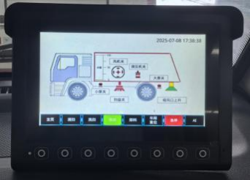
The rear control panel is primarily used for waste hopper unloading, commissioning and maintenance.Color Video Rear-View System (Optional): Cameras are mounted on the rear of the vehicle and on the right-side working assembly, there is a high-definition color display inside the cab. During operation, operators can monitor and inspect cleaning performance from the cab.When reversing, the display automatically switches to the rear-view camera.Multiple Operation Modes: The system offers two working modes — Sweeping and Full Washing & Sweeping. Once the working mode is selected, simply to touch starts theoperation, all mechanisms automatically starting works. When stopping operation, one touch halts, then all mechanisms automatically shut down and retract.

五、Products Technical Parameters
Item |  | Parameter | Remarks
Overall Dimension（L×W×H）(mm) |  | 3980，4030，4360×1240，1350，1430，1630×1860，1870
Maximum Gross Vehicle Weight (kg) |  | 1950
Curb Weight (kg) |  | 1500
Rated Loading Weight (kg) |  | 385
Minimum Turning Diameter (m) |  | 11
Minimum Ground Clearance (m) |  | 135
Maximum Speed (km/h) |  | 71
Range Mileage(Constant Speed) (km) |  | 150
Wheelbase (mm) |  | 2355
Front Overhang/ Rear Overhang (mm) |  | 475/1150,475/1200
Approach Angle/ Departure Angle (°) |  | 34/8,34/10,15/10
Seating Capacity (persons) |  | 1
Chassis Model |  | ZB1022BEVGDRJ0
Type of Energy Storage |  | Lithium Iron Phosphate
Chassis Battery Capacity （kWh） |  | 16 | Total Battery Energy: 32 kWh
Upper Structure Battery Capacity（kWh） |  | 16 | Total Battery Energy: 32 kWh
Total Assembly Nominal Voltage（V） |  | 307.2
Chassis Electric Motor | Type | Permanent Magnet Synchronous Motor PMSM
Chassis Electric Motor | Model | TZ170XZD3
Chassis Electric Motor | Electric Motor Rated Power/Speed/Torque（kW/r/min/N. m） | 10/3820/25
Chassis Electric Motor | Electric Motor Peak Power/Speed/Torque（kW/r/min/N. m） | 27/9000/105
Charging Connector: To support slow charging,fast charging
Specialized Function Parameter | Water Tank Capacity（L） | 700
Specialized Function Parameter | Garbage Tank Capacity（L） | 800
Specialized Function Parameter | Sweeping Diameter/Speed（mm/rpm） | φ630/60-100 Adjustable
Specialized Function Parameter | Front Washing System | Opposite jet, linear jet, side jet
Working Performance | Maximum Sweeping Width（mm） | 1800 (Sweep the outer edge)
Working Performance | Sweeping Speed（km/h） | 5-10
Working Performance | Water Rated Pressure （Mpa） | 15
Working Performance | Water Rated Flow（L/min） | 20
Working Performance | Sweeping Efficiency（%） | ≥95
Working Performance | Sweeping Noise（dB） | ≤78
Working Performance | Maximum Cleaning Capacity （㎡/h） | 18000
Working Performance | Uploading Method/Uploading Angle(Angle between the inclined surface of boat-shaped hopper and the ground） （°） | High-level Discharging/≥42°
Working Performance | Charging Period（SOC:20%-80%）（h） | 6-8 hours slow charging via AC communication / 45 minutes DC fast charging
Working Performance | Sweeping Operation Time （h） | 6-8
Running Performance | Maximum Slope Angle（%） | 20
Running Performance | Brake Distance(full loading 30km/h） | 5

六、Function configuration
 | Item | Pics | Parame ter | Description | Remarks
1 | High  Pressure  Sweeping | 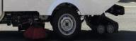 | Sweepin  g Width 1m | Used to remove stubborn  contamination from road surfaces; Scrubbing curbs and curb stone vertical faces . | Standard Option
2 | Handle  Spray  Gun+  coiled tube pan | 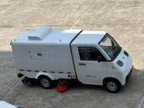 | / | It is strictly prohibited to point the  spray gun nozzle at personnel during operation . It can effectively scrubbing contamination, street posters,  advertisement boards along both sides of the road , delivering ,with high cleaning efficiency and good effect. | Standard Option
3 | Garbage  container  self-clea ning | / | High  pressure  self-clea ning | Used for garbage container self-cleaning | Standard Option
4 | Maintenan ce  pushcart | 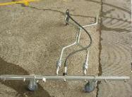 | Sweepi ng  Width 1.5m | In the road sections where the  vehicle cannot conveniently park , the pushcart can be used for cleaning. It is fitted with a SS tube handrail and aluminum alloy  pressure-resistant spray bar , make it lightweight , elegant in appearance and reliable performance . | optional
5 | Front  sprinkler frame | 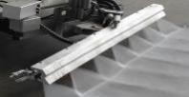 |  | It features front high pressurereverse flushing, high pressure scrubbing road surface . | Optional

七、Products Advantages
1.High-Performance Chassis Built on a single-seat chassis with an overall body width of only 1,350 mm, it offers excellent maneuverability and a small turning radius. The rear
wheel load-bearing suspension supports high payload capacity, both DC charging and AC charging are supported,The chassis is equipped with electric power steering (EPS),
hydraulic braking front disc / rear drum, cooling heating air conditioner, ABS, and EBS brake vacuum booster system, delivering flexible steering and reliable braking.
2.Driver’s Cab, the seat is adjustable front and rear,and fitted with a three-point safety belt. Multi- functional dashboard, equipped with GPS positioning terminal, an on-board fault
self-diagnosis system, and a reserved OBD communication port. Cooling heating air conditioning ensures comfortable working environment. A rear-view camera enhances operational visibility.
3.Battery system, the chassis is powered by lithium iron phosphate (LFP) battery with strong endurance and stable performance. An additional upper-body supplementary battery with the same brand and capacity which brings the total battery capacity to 32 kWh. Both battery packs share one single charging port, charge/discharge simultaneously, which provide 6–8 hours of continuous operation on a full charge.
4.Driving motor and heavy loading tires, the vehicle is driven by a high-performance 10 kW permanent magnet synchronous motor (PMSM) delivering strong, stable power. It is fittedwith 145R12LT heavy loading tubeless tires for high load capacity. All electrical components and wiring harnesses have a protection rating of IP67 or higher for enhanced safety and durability.
5.Upper body rotational moulding water tank, the rotational moulding integrate water tank features a lightweight design with an elegant appearance, color and styling can becustomized according to customer requirements. It has characters of long service life. With big capacity of 700 L and multiple filling options (side or top filling), it extends continuous operation time and avoid of frequent refills.
6.Upper structure high-dump SS Tank, the sewage tank adopts boat-shaped structure,made of 304SS or 201SS material. Tank body processed with bending forming, welded then pressure-tested, solid structure, which eliminating the leakage and dripping issues. The top lid is opened and closed by a hydraulic cylinder and lined with sealing strips. With a dumping height exceeding 1.1 m, sewage and waste can be discharged with 660 L waste bins or waste compactor trucks, in avoid of secondary contamination.
7.Upper structure one-touch remote control and touchscreen operation, The remote control with function of start/stop, broom lifting/lowering, fan control, suction nozzle operation,dumping and tank lowering. The touchscreen adopts CAN bus control, easy to operation, key functions are completed with a single touch, and all operation can be controlled bytouchscreen from the cab.
8.Hydraulic unit and components, it utilize 2.2 kW hydraulic power unit delivers smoothoperation and stable performance. Unloading is performed by double-acting cylinder rear high lift, with rated pressure of 16 MPa.
9.Powerfull functionality,In addition to standard option like washing & sweeping, coiler, fan cleaning, and sewage tank cleaning, it also equipped withhand-held suction and high-pressure water gun. Optional road maintenance functions include front flushing,opposed flushing and spot flushing, further more, snow removal roller brush is also available as an option.

