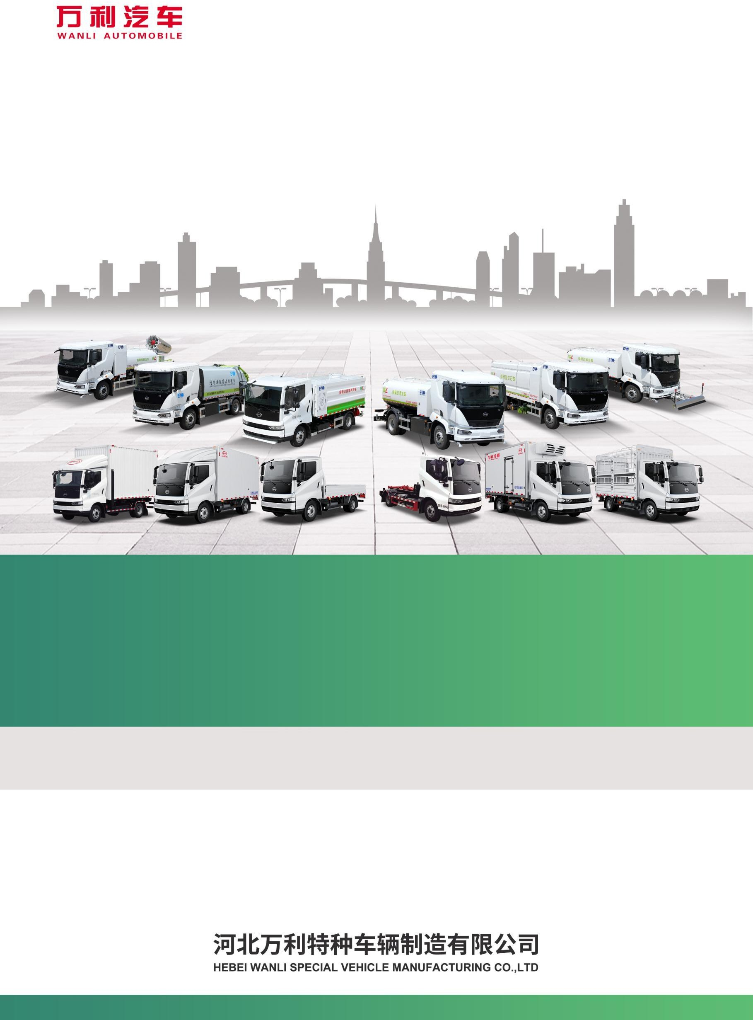

Brochure for Pure Electric Kitchen Waste Truck
HWL5090TCAFTBEV 型
2026年3月第一版

一、Product Overview
The kitchen waste truck is modified based on the pure electric chassis of Foton BJ1098EVJA3 Type II cargo vehicle manufactured by Beiqi Foton Motor Co., Ltd., fitted with components including garbage bin, pushing-blade, feeding mechanism, hydraulic system and electrical system. The vehicle is fully enclosed and adopts mechanical-electrical-hydraulic integrated technology. With the help of a combined mechanical- electrical-hydraulic automatic control system, it realizes waste collection and unloading via special devices such as garbage bins, feeding mechanisms and push-blade.
This product is a special vehicle for the collection and transportation of kitchen waste from hotels, restaurants, enterprises and institutions.
The waste bin enables preliminary solid-liquid separation of kitchen waste inside the tank. Equipped with a large-capacity sewage tank, it improves the product loading capacity.
The electronic control system adopts wireless remote control. Logical interlock for working actions is implemented to guarantee accurate operation and eliminate misoperation.

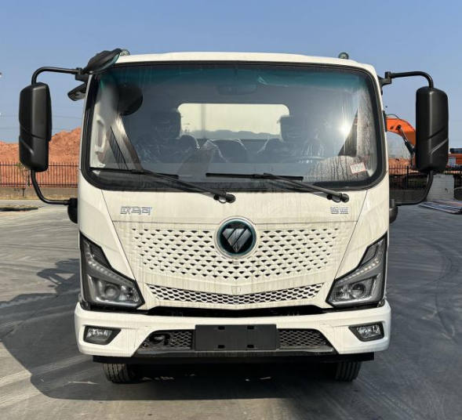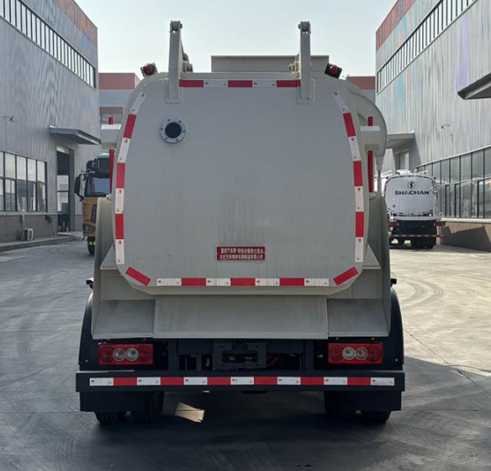

Front Rear
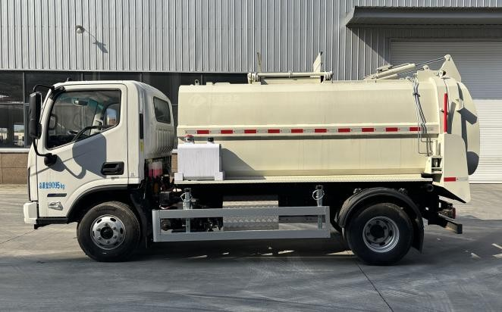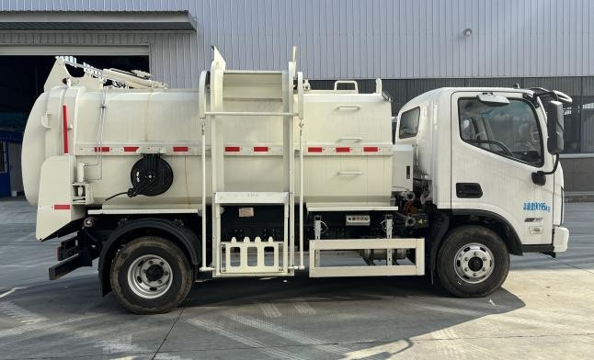
Left Right

二、Function Overview
The kitchen waste truck is modified based on a Class II chassis. The main core superstructure components include: a tank for storing kitchen waste, multi-way valve, hydraulic cylinder, high-pressure oil hose, garbage bin-lifting mechanism, hydraulic push plate inside the tank, filter plate, locking hook, ball valve, clean water tank, hydraulic motor, high-pressure pump, heating device, weighing device, monitoring system and so on.
It refers to special vehicles used for the collection and transportation of domestic waste and food waste(swill).

三、Scope of Application
It is applicable for commercial catering enterprises, hotels, schools, hospitals and other places to collect kitchen waste, leftover food and other relevant garbage.

四、Main Technical Parameters of the Product
Item |  | Parameter
Announcement Number by MIIT | Wanli’s Vehicle Announcement Number by MIIT | HWL5090TCAFTBEV
Announcement Number by MIIT | Chassis Announcement Number by MIIT | BJ1098EVJA3
Mass Parameters | Maximum Gross Vehicle Mass（kg） | 9095
Mass Parameters | Curb Mass（kg） | 5130
Mass Parameters | Rated Payload Mass（kg） | 3770
Dimension Parameters | Overall Dimension (mm) | 5820×2300×2750
Dimension Parameters | Wheelbase (mm) | 3360
Dimension Parameters | Approach / Departure Angle (°) | 20/16
Dimension Parameters | Front / Rear Overhang (mm) | 1120/1340
Dimension Parameters | Front / Rear Track Width (mm) | 1590/1700
Power Battery Parameters | Battery Type | Lithium Iron Phosphate
Power Battery Parameters | Battery Manufacturer | Contemporary Amperex Technology Co., Ltd.(CATL)
Power Battery Parameters | Battery Pack Model | L185E01
Power Battery Parameters | Battery Capacity (kWh) | 100.07
Power Battery Parameters | Nominal Voltage (V) | 540.96
Power Battery Parameters | Nominal Capacity (Ah) | 185
Power Battery Parameters | Traction Battery System Energy Density (W·h/kg) | 145.3
Motor | Manufacturer / Model | Beiqi Foton Motor Co., Ltd.  /FTTBP200A
Motor | Motor Type | Permanent Magnet Synchronous Motor
Motor | Rated / Peak Power (kW) | 92/200
Motor | Rated / Peak Torque (N·m) | 220/450
Motor | Rated / Peak Speed (rpm) | 4000/12000
Chassis Motor Controller | Model | FTIVT280B1
Chassis Motor Controller | Manufacturer | Beiqi Foton Motor Co., Ltd.
Other | Maximum Speed (km/h) | 90
Other | Driving Range (Test Cycle) (km) | 311

五、Main Structure and Performance Characteristics

Waste Container and Rear Door
The waste container is a component for collecting and storing kitchen waste, and also serves as the connecting base for key components including the rear door, push-blade, chassis and bin-lifting mechanism.
Structures such as the garbage container, rear door and clean water tank are made of 304 stainless steel, featuring corrosion resistance and rust resistance.
A clean water tank is designed at the front of the waste container, and a sewage tank is installed at the bottom to realize preliminary solid-liquid separation of kitchen waste. The waste bin and rear door are sealed with specially designed reinforced silicone strips, which offer excellent sealing performance and prevent secondary pollution.

Bin-lifting Mechanism
The bin-lifting mechanism is a component for dumping kitchen waste from waste bins into the waste container. Driven by a hydraulic cylinder, it completes dumping and resetting via a tie-rod linkage mechanism. The bin-lifting mechanism can be optionally fitted with a weighing system upon customer request for waste weight metering. The opening and closing of the feeding-port cover is connected to the bin-lifting mechanism via a mechanical linkage.

Unloading Mechanism
The system employs a push-blade for unloading; the push-blade is driven by hydraulic cylinders and slides along the waste container tracks using wear-resistant nylon sliders; preliminary solid-liquid separation can be achieved through the circular holes on the push-blade panel.
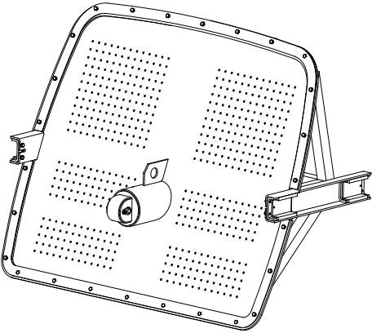

Safety Devices
The vehicle is equipped with an emergency stop switch. Pressing the switch in an emergency can rapidly stop all movements of the superstructure. The central control screen in the cab and the rear operation panel adopt mutual software logic interlock to avoid safety accidents caused by conflicting operations by operators at the two positions.
A safety prop is installed at the rear of the container. When the rear door is lifted for maintenance, set up the safety prop to prevent accidents. It is equipped with a voice-alarm warning system. When the rear door opens or closes, the voice annunciator sends safety prompts to warn nearby personnel.

Sealing Performance
The waste container and rear door are sealed with specially-made reinforced silicone strips. A hydraulic locking mechanism provides compression between the waste bin and the rear door for excellent sealing performance to prevent secondary pollution. The hydraulic locking mechanism and the rear door achieve logically-sequenced actions through software logic interlock.

Side-guard

The side-guard assembly is assembled from aluminum-alloy cross beams and high-quality brackets, featuring a sleek appearance.

Electric Control System
It adopts a control mode consisting of a center-console display, a controller and a wireless remote controller.

Central Control Screen
Equipped with a 7.0-inch touch-enabled central control screen. Protection rating: IP65; 800 ×480 TFT resolution. Functions: monitor signal status of proximity switches and sensors; display superstructure fault codes; monitor and display electrical parameters of superstructure motors and electric control components, etc.
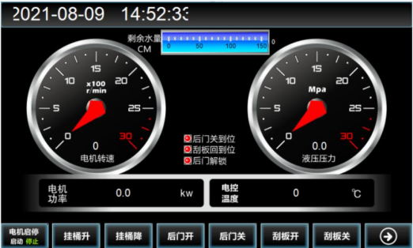
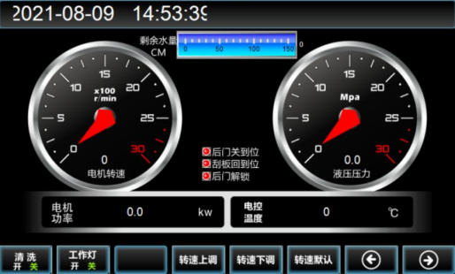

Figure 1 Central Control Screen

Wireless Remote Controller
The vehicle adopts a wireless remote controller for operation, which is portable and easy to operate.
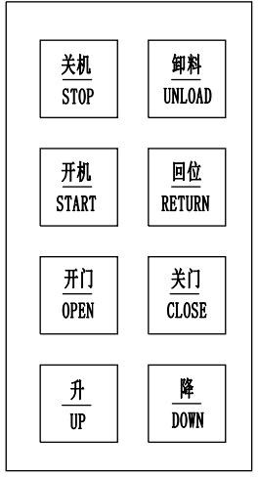

Type II Chassis

It adopts the Model BJ1098EVJA3 type II chassis of cargo truck manufactured by Beiqi Foton Motor Co., Ltd. This chassis is specially custom-developed for kitchen-waste trucks and features compact layout.

Power Battery
The power battery of this vehicle is the Model L185E01 lithium-iron-phosphate battery pack manufactured by Contemporary Amperex Technology Co., Limited (CATL).
The battery system is equipped with heating films to meet the operation requirements in cold northern regions.
It provides multiple protections against over-temperature, over-charge, over-discharge and short-circuit, featuring stable performance, high safety and reliability.
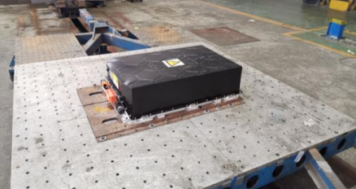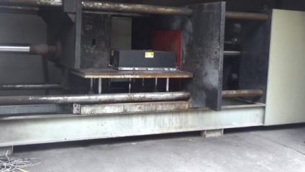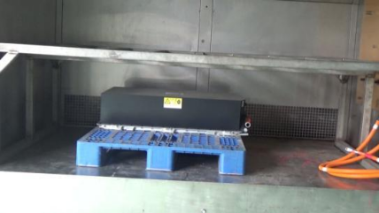
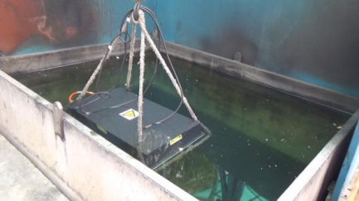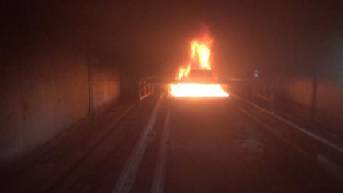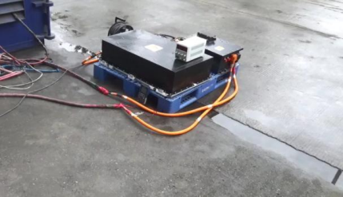
Figure 2 Battery Mandatory Inspection Test

Drive Motor
The chassis is equipped with a 200 kW high-torque, high-efficiency permanent-magnet synchronous motor (PMSM) manufactured by Beiqi Foton Motor Co., Ltd. Featuring proven reliability and rail-grade quality standards, it is matched with a motor controller supplied by Shanghai Xin Power Technology Co., Ltd. It delivers comfortable and economical driving performance for electric vehicles and achieves a gradeability of over 25%.

Five-in-one Controller
The chassis is fitted with the five-in-one controller developed by Beiqi Foton Motor Co., Ltd., which integrates five functions: power-assisted steering motor control, air-compressor motor control, DC/DC converter, high-voltage power distribution, and high-voltage pre-charging power-take-off for the superstructure. Three high-power power-take-off interfaces of 20kW, 60kW and 120 kW are reserved for superstructure power distribution to meet the electrified power-take-off requirements of various types of superstructures.
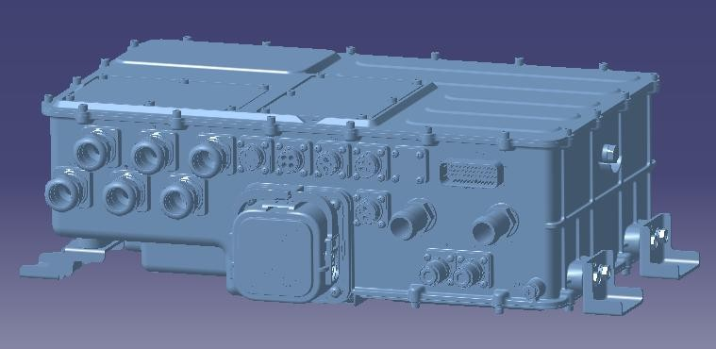
This five-in-one controller adopts an integrated design, which greatly improves power density. Meanwhile, it features high intelligence, high stability and high safety.

Safety Protection
Leakage Detection: When the vehicle is powered on, the insulation detection module can monitor the whole vehicle for electric leakage.
Multi-layer Protection: During normal charging and discharging, the vehicle controller, main control unit, auxiliary control unit and battery management system (BMS) implement multi-layer monitoring and protection of the current flow to guarantee high-voltage safety.
Active Discharge Function: After vehicle power-off, the voltage of high-voltage electrical components drops rapidly to a safe voltage below 36 V to ensure operational safety.

六、Main Structure and Performance Features

User-Friendly Operation Control
The vehicle is equipped with both a central-control screen and a wireless remote controller for operation control. The central-control screen in the cab can perform all operation commands. It also monitors signal status of proximity switches and sensors, displays superstructure fault codes, and monitors and shows electrical parameters of superstructure motors and electronic controls.

Advanced Control Technology
Motor performance parameters are precisely configured according to the actual working conditions of the kitchen-waste truck. Different movements are equipped with corresponding motor speeds based on operational requirements. The throttle valve is eliminated to avoid power loss and system heat build-up, resulting in low energy consumption, low noise and excellent economic efficiency.

Information-based Technology
Equipped with a full set of sensors to collect diverse data and build a large-scale database. It can predict potential fault points. When a fault occurs, the monitoring platform enables rapid fault identification and resolution. Big-data analysis supports accurate evaluation of vehicle operating conditions.

