Electric Compactor Garbage Truck Presentation
HWL5180ZYSBYDBE

一、Product Overview
The HWL5180ZYSBYDBEV electric garbage compactor truck was developed by Hebei Wanli Special Vehicle Manufacturing Co., Ltd.. It is a new generation of specialized transportation & operation vehicles which is applicable for urban waste collection and cleaning.
It is a high-end intelligent rear-loading garbage compactor truck, which is modified based on BYD1180C2BEVC1 100% electric class II freight chassis, equipped with garbage container, compactor, push shovel, feeder device, hydraulic system, electric system and other components. The superstructure consists of sealed garbage container, compactor, push shovel, hydraulic transmission system and electric control systems. It is full sealed vehicles which adopted electro-hydraulics integration technology, by adopt electro-hydraulics combined automatic control system, using garbage container, compactor, shovel device and specialized device, so waste can be poured, crushed or compressed, powerful loaded, pushing waste into garbage container then compressing and discharging. Sewage compressed by waste can get into the tank, problem for 2nd time pollution during garbage transportation can be solved
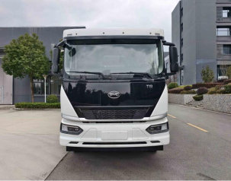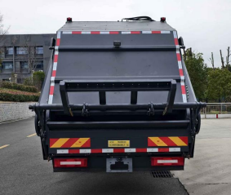
Front Rear
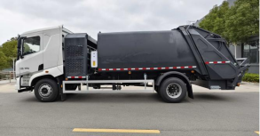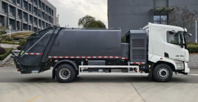
Left Right
二、Function Overview
It has multiple functions including waste collection, automatic loading and compression, transportation and unloading.
三、Application Area
It is mainly applicable to the collection and transfer of barreled, bagged and bulk domestic waste in urban residential areas, communities, large factories and mines, government agencies, schools and narrow streets in old urban areas.

四、Product Main Technical Parameter

Item |  |  | Parameter | Remarks
Announcement No. By MIIT | Vehicle Announcement No. |  | HWL5180ZYSBYDBEV
Announcement No. By MIIT | Chassis Announcement No. |  | BYD1180C2BEVC1 | /
Mass Parameters | Maximum Total Mass (kg) |  | 18000 | /
Mass Parameters | Rated Loading Capacity （kg） |  | 4820
Mass Parameters | Curb Weight （kg） |  | 13050
Dimension Parameters | Overall Dimension (mm) |  | 10120, 10055,9850×2550×3280 | /
Dimension Parameters | Wheel Base（mm） |  | 5300 | /
Dimension Parameters | Front/Rear Overhang (mm) |  | 1600/2900, 1600/2855
Dimension Parameters | Approach/Departure Angles ( ° ) |  | 16/10
Battery | Battery Type |  | Lithium Iron Phosphate
Battery | Battery Capacity（kWh） |  | 251.392, 276.531
Battery | Nominal Voltage （V） |  | 512,563.20
Electric Motor | Manufactuer/Model |  | BYD /TZ370XSA
Electric Motor | Type |  | Permanent Magnet Synchronous Motor(PMSM)
Electric Motor | Rated/Peak Power(kW) |  | 160/250
Other Parameters | Maximum Speed（km/h） |  | 89 | /
Other Parameters | Endurance Mileage(km) |  | 385,425 | Constant Speed
Other Parameters | Charging Time（h） |  | 1.7
Superstructure Parameters | Container Capacity（m³ ) |  | 14
Superstructure Parameters | Feed Hopper | Ground Clearance Height（mm） | 1145
Superstructure Parameters | Feed Hopper | Inner Wide(mm) | 1940
Superstructure Parameters | Feeder Capacity（m³ ) |  | ≥1.75
Superstructure Parameters | Sewage Container Capacity（L） |  | 430 +270
Superstructure Parameters | Single Loading Circulation Time（s） |  | 16～18
Superstructure Parameters | Single Refuse Discharge Time （s） |  | 22
Superstructure Parameters | Hydraulic System Rated Pressure（MPa） |  | 18

五、Main Structure and Performance Character
1. Garbage Container
The garbage bin adopts a frame structure welded with reinforced beams and steel plates, with arc-shaped curved surfaces on the side and top faces. The strength grade of the materials shall not be lower than Qste420tm. The thickness of the left side plate, right side plate, bottom plate and front plate of the garbage bin is 4 mm. The strength grade of the material for the main beams of the garbage bin underframe shall not be lower than Q355B with a thickness of 5 mm, and the thickness of other auxiliary load-bearing beam plates made of Q355B is 3 mm.
2.Push Shovel
The push shovel consists of rectangular tube frame and folded steel plate. The push shovel plate is made of 3mmQ355B, other main structure materials’ thickness is 4mm. The gap is uniform between push shovel and container(gap should be ≤ 5mm) , which ensures complete garbage unloading and avoids interference with the garbage bin. The sliding block of the push shovel track adopts nylon sliding block for guiding, and the track is made of Qste420tm with a thickness of 6 mm.
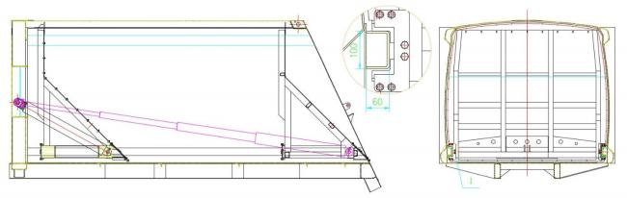
Pics 1 Sections view of push shovel’ track,slider and assembling.
- Compactor
The compactor consists of compactor shell, sliding plate, scraper plate, and other components. Compactor itself made of steel plate with yielding strength more than Q355B, each components structure are solid, light weight; compactor’s left and right plate (lower side plate made of 5mmQste420tm steel plate, and upper side plate made of 4mmQ355B steel plate) the hopper bottom made of 6mmQste420tm steel plate, compactor’ sliding guide rail made of QSTE420TM high strength steel plate bending forming finish, other bearing components made of steel with yield strength more than Q355B, while the thickness no less than 2.5mm, the compactor bottom sewage container made of Q355B steel plate, the thickness is 4mm. Compactor and body conjunction adopted lifting linkage locking mechanism, sliding rail slider adopted Nylon slider, nylon slider’s material is PA66.
4. Feeder Device
Capable of tipping over 2 pieces of 240L national standard plastic trash cans, 1 piece of 660L national standard plastic trash can and 1 round iron barrel. The barrel tipping mechanism operates smoothly. The tipping angle (the included angle between the barrel hanging frame and the horizontal line of the ground) shall be no less than 45 degrees. All waste can be completely poured into the feeding hopper of the loader in a single tipping operation without waste leakage, residue or incomplete emptying. The vertical height from the topmost part of the hanging teeth on the barrel holder of the tipping frame to the ground shall not exceed 900mm.
- Compactor cover
It is installed at the opening of compactor’s cover for shield compactors bucket, the compactor cover is a component in avoid of waste leakage as well as odor leakage, to open and close it by cylinder driving, to make the garbage container and compactor to be fully sealing.
- Side Protection Rail
Industrial exterior design, with skirt edge structure, design integrated with container with character of beautiful, simple and elegant
- Electric Control System
It adopted “display panel+ controller +CAN bus operational panel” control model. Ensuring all operational commands locking each others, there is central control screen installed inside the cab, the CAN operational panel installed at rear, to be used for tasks operation.
8. Central Control Penal
It adopted 7.0 inch central control screen with touching function, protection class IP65, resolution ratio 800*480TFT. Monitoring status near to switch, sensor signal, superstructure error code display, superstructure’s motor, electric control parameters, and display etc.
9. Rear Optional Control Panel
It is located at right side of compactor, mainly applied for operation of hang container and loading mode.
- Safety Configuration
It adopted with emergency switch, to press emergency button to stop all operation of superstructure in case of emergency. It is equipped with Anti-drop switch, to press anti-drop switch during vehicle maintenance and repairing, to prevent safety accidents caused by personnel's improper operation.
Mutual software logical interlock is implemented between the central control screen in the cab and the rear operation panel to prevent safety accidents caused by conflicting operations of personnel at the two positions.
Safety rod installed at rear of body, which can be extended during feeder lifted for repairing, which can in avoid of safety accident.
Voice Alert caused by voice speaker during vehicle lifting and unloading the compactor, alarming safety for peoples around.
- Optional Device
Different users can optionally install different bin tipping (hopper) mechanisms according to various waste collection methods: tipping device for standard metal waste bin ZBT59003-88 (300L), plastic waste bin (240L), plastic waste bin (660L), on-board small waste hopper (800L), covered sealed waste hopper (1400L), and swing-arm waste hopper (3000L).
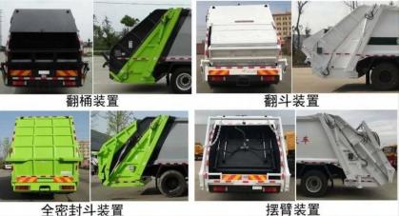

六、Product Advantage
1. High strength for loading, and high efficient for tasks
It adopted advanced two side compressing technology, with high strength for compression, leading in industry. Fast loading, fast for loading and discharging tasks in once circular time, high efficient and quick for waste collection and transportation.
2. Loading device has character of high adaptability, high reliability
Loading method coverage major collecting way, includin: reverse trash can 120L/240L/660L, reverse round iron type trash can, and tipping type.
3. Environmental Friendly
Compactor’s cover can fully coverage the feeder opening, eliminated phenomenon of dust particle flying, it also reduced odor pollution.
4. Humanized operation control
Tasks operation control adopted central control panel and rear operation panel, the central control screen in cab can control push shovel, discharging, to choose operation model, and monitoring status near to switch and sensor signal; superstructure error code, superstructure motor, electric control and electric parameters, and display etc.
The operation panel installed on rear can control tasks for compactor superstructure, very easy operation, especially in the landfill, worker can finish discharging without getting out of the cab.
- Advanced control technology
Electric motor parameters can be allocation precisely according to vehicle’s specific tasks scenario, adaptable motor speed can be set as per requirement of different tasks, canceled throttle valve, in avoid of power consumption and system heat, with character of lower consumption, lower noise and economic performance.

