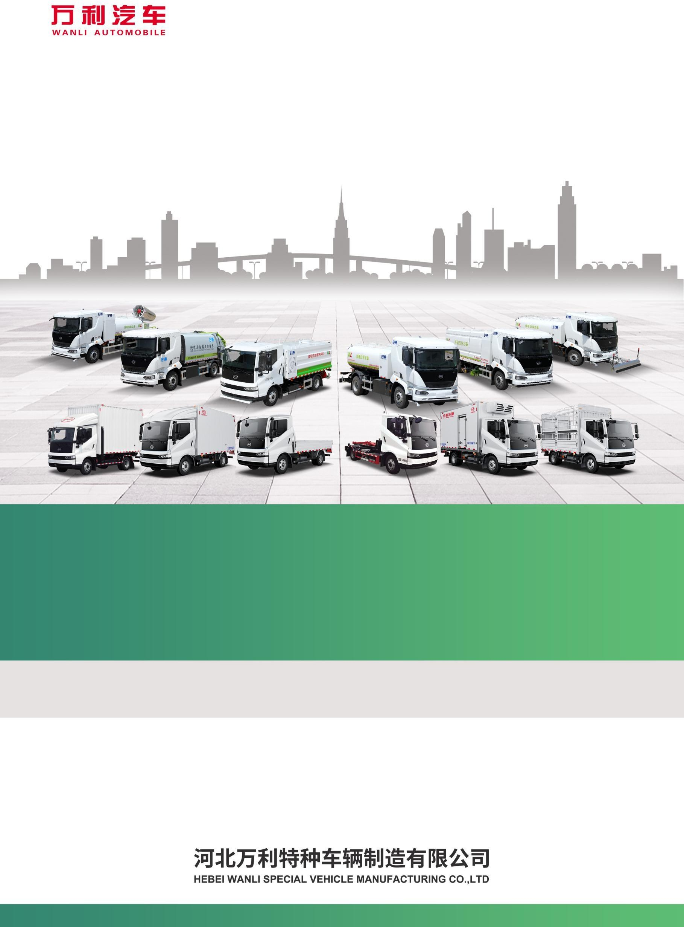

Brochure for Pure-electric Washing and Sweeping Vehicle

HWL5188TXSBEV 型
2026年3月第一版

- Product Overview
Model HWL5188TXSBEV battery-electric sweeping-washing vehicle is a new-generation special equipment independently designed and developed by Hebei Wanli Special Vehicle Manufacturing Co., Ltd. It features proprietary intellectual property rights and internationally-leading technologies for road surface and curb cleaning, sweeping and spray dust suppression.
This washing and sweeping vehicle integrates the functional features of street sweepers and high-pressure washing trucks. It overcomes the limitation of vacuum sweepers, which are unable to clean curbs on urban roads. During operation, the brushes sweep road debris toward the inner side of the vehicle. Stubborn surface attachments are loosened by water jets from high-pressure spray bars, then sucked into the waste bin via suction nozzles for storage. It features environmental-friendly performance, multiple functions, rational design, low energy consumption, wide cleaning coverage and long service life. Built on an electric-drive chassis, it delivers genuine Class-II battery-electric performance, boasting advantages including zero pollution, zero emissions, low noise and stable operation.
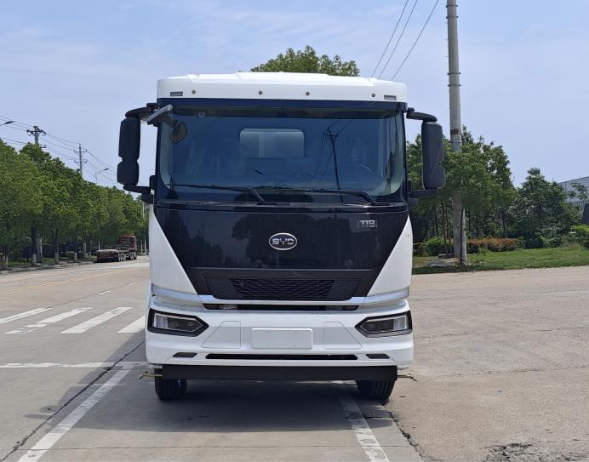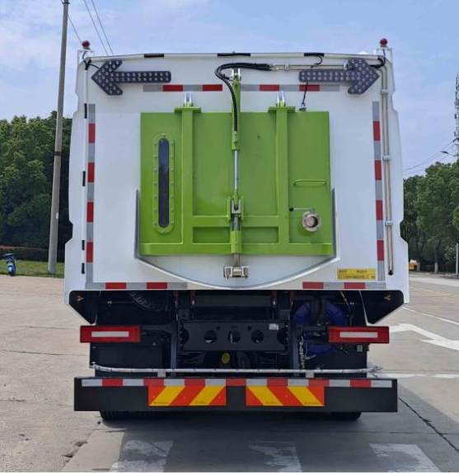
Front Rear
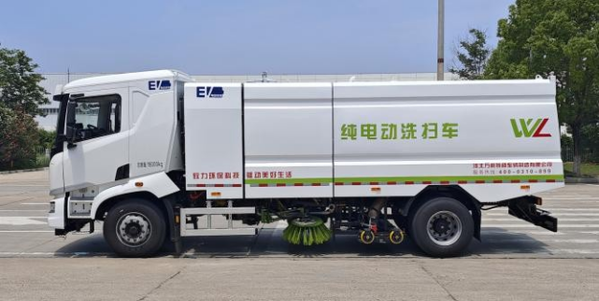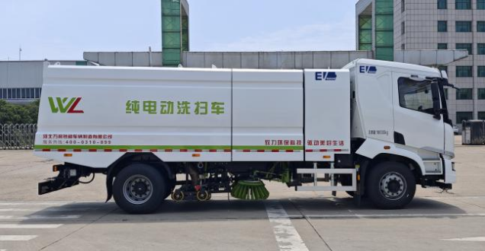
Left Right
II. Functional Overview
The Fuyan brand battery-electric sweeper-washer is multi-functional, capable of road surface washing, road sweeping, curb cleaning, vertical-surface scrubbing of curbstones, and spray dust suppression. Multiple working modes are available for selection, including “Full Washing-Sweeping”, “Left Washing-Sweeping”, “Right Washing-Sweeping”, “Full Sweeping”, “Left Sweeping” and “Right Sweeping”. When the “Full Washing-Sweeping” mode is selected for cleaning squares and road surfaces, it achieves high-efficiency and excellent cleaning performance with a cleaning rate of over 90%. The “Left Washing-Sweeping” or “Right Washing-Sweeping” mode can be adopted to clean road surfaces, curbs and vertical faces of curbstones. For road sweeping or road maintenance work, the road-sweeping mode may be activated. For dust suppression, the spray device can be turned on to carry out spray dust-reducing operations.
The operating system features dual control of computer control and manual operation, which effectively guarantees and improves the vehicle availability rate.
III. Scope of Application
1.Cleaning of road surfaces and curbs for urban roads, expressways, squares, airports, docks, tunnels, bridges, separation walls and so on.
2. Washing and sweeping of main roads at construction sites, factory premises and similar areas.
IV. Main Structure and Performance Characteristics
1. Structure
This washing and sweeping vehicle is modified based on a Class-II pure electric chassis, equipped with a fan, clean water tank, waste bin, left and right vertical sweepers, sweeping disc dust suppression system, left and right high-pressure side spray bars, built-in high-pressure main spray bar inside the suction cup, pneumatic system, hydraulic system, electronic control system for special devices and auxiliary frame.
The vehicle is fitted with an independent Beidou satellite positioning system.
The switches on the cab instrument panel are arranged in the middle of the central dashboard, including three switches: Motor Start/Stop, Left Spray and Right Spray. They control the start and stop of the upper-mounted motor, as well as the optional functions of low-pressure left water spraying and low-pressure right water spraying.
- Chassis
The vehicle adopts BYD Class-II pure-electric chassis with well-matched assemblies, which fully complies with all national regulatory requirements for new-energy product chassis and delivers high reliability. Its features are as follows:
- The power battery adopts rear-mount layout. The cab comes standard with central locking, and MP5 player. It is fitted with wrap-around aviation air-bag shock-absorbing seats with high-density sponge. More than 10 storage spaces including cup holders, card slots and storage boxes are provided to deliver a comfortable driving and riding experience.
- The vehicle features lightweight design with a maximum gross vehicle mass of 18000 kg.
- Equipped with a large-capacity power battery, it meets the application requirements of various sanitation washing vehicles and garbage collection-transport vehicles. The power battery is standard-fitted with a water-circulation thermal management system to satisfy vehicle operation under diverse environmental conditions.
- Fitted with a high-power power-taking interface for superstructures, it meets the electrification requirements for various special-vehicle superstructures.
- Zero-pollution and low-noise, it effectively protects the environment, saves fuel energy and delivers lower operating costs.
- Strong chassis load-bearing capacity: dual rear tires, with a maximum gradeability of over 30%, suitable for operation under various road conditions.
- Sedan-style interior and comfort-oriented configurations with electronic control operation.
- Safe and reliable: equipped with BYD, a high-end domestic battery brand.
- Additional configurations: main power switch and battery heating system.
- The vehicle is equipped with large-capacity battery, enabling worry-free long-hour operation.

3. Product Performance Features
The washing-sweeping vehicle is refitted based on BYD battery-electric Class-II chassis, retrofitted with fan, high-pressure water pump, clean-water tank, garbage bin, left-and-right vertical sweepers, wide suction nozzle with water spray bar, sweeping disc dust suppression system, hydraulic system, electric control system for special equipment and sub-frame, etc.
The chassis motor drives the fan and high-pressure water pump. A 7.1B-L0 high-pressure centrifugal fan is adopted, featuring high efficiency and large air volume, with a maximum airflow of 23500 m³/h. The high-pressure water pump is an internationally renowned AR plunger pump, delivering proper flow rate and high pressure, with a maximum allowable pressure of 10 MPa.
The left and right vertical sweepers adopt dual sweeping discs. Independently-controlled left and right-side sweeping enables multiple operation modes including left-side sweeping, right-side sweeping and full-width sweeping. The suction opening of the wide suction nozzle measures 2418 mm, ensuring an overall working width of over 3.5 m. Four height-adjustable nozzle wheels allow multi-directional adjustment to maintain a proper clearance between the suction nozzle and road surface. A high-pressure water spray bar is built inside the suction nozzle. As many high-pressure washing nozzles as possible are arranged within the nozzle, which not only delivers superior cleaning performance, but also minimizes secondary pollution caused by debris stirred up by high-pressure water-air flow.
The left and right water spray robs are installed on the suction cups, which rise and fall with the suction cups. The structure is simple and compact to ensure that the height of the spray rods from the ground remains constant and achieves the best cleaning effect. The open-circuit hydraulic system drives the left and right vertical sweeping lifting, the left and right sweeping disc rotation, the suction nozzle lifting, the opening and closing of the waste bin rear door, and the tipping and resetting of the waste bin.
The AR high-pressure water pump is motor-driven with stepless adjustable flushing pressure, meeting the requirements for efficiency improvement, energy saving, consumption reduction and environmental-friendly operation.
Adopting a square box structure, it greatly increases the box volume and enhances the overall vehicle appearance.
V. Main Technical Parameters of the Product
Item |  | Parameter
Announcement No. | Vehicle Announcement No. | HWL5188TXSBEV
Announcement No. | Chassis Announcement No. | BYD1180C2BEVC1
Mass Parameters | Maximum Total Mass (kg) | 18000
Mass Parameters | Curb Weight (kg) | 12600
Mass Parameters | Rated Payload (kg) | 5270
Dimension Parameters | Overall Vehicle Dimension (mm) | 9120×2550×3280
Dimension Parameters | Wheelbase (mm) | 5300
Dimension Parameters | Front Track / Rear Track (mm) | 2055/1860
Dimension Parameters | Front Overhang / Rear Overhang (mm) | 1600/2220
Power Battery | Battery Type | Lithium Iron Phosphate
Power Battery | Battery Manufacturer | Wuhan FinDreams Battery Co., Ltd. (Cell)  FinDreams Battery Co., Ltd. (PACK)
Power Battery | Battery Capacity (kWh) | 276.53
Power Battery | Nominal Voltage (V) | 563.20
Motor | Manufacturer / Model | BYD Auto Industry Co., Ltd.  / TZ370XSA
Motor | Type | Permanent-magnet Synchronous Motor
Motor | Rated / Peak Power (kW) | 160/250
Motor | Rated / Peak Rotational Speed (r/min) | 2315/4500
Motor | Rated / Peak Torque (N·m) | 660/1060
Others | Maximum Speed (km/h) | 89
Others | Driving Range(Constant-speed Method) (km) | 425
Others | Approach / Departure Angle (°) | 16/11
Others | Number of Cab Occupants | 2
Tank Parameters | Clean-water Tank Volume (m³) | 8.5
Tank Parameters | Garbage Bin Volume (m³) | 7
Special-purpose Performance Parameters | Sweeping Width (m) | 4
Special-purpose Performance Parameters | Low-pressure Flushing Width (m) | 14
Special-purpose Performance Parameters | Charging Time (h) | Approx. 2-3 h for single-gun fast charging, 0.9 h for dual-gun fast charging, approx. 8-10 h for slow charging
Special-purpose Performance Parameters | High-pressure Water Pump Pressure (MPa) | 10
Special-purpose Performance Parameters | High-pressure Water Pump Flow (L/min) | 150

VI. Main Product Advantages
- Low Operating Cost
Electricity cost is much lower than fuel cost. Meanwhile, the maintenance cost of the motor is lower than that of an engine. Coupled with the high reliability of BYD batteries, the overall maintenance expense is significantly reduced.

Efficiency and Cleaning Performance
It achieves a cleaning rate of over 90%. Multiple operation modes reduce repetitive work, increase the cleaning area per unit time, and indirectly cut labor costs.
- Policy Adaptability
With zero-emission and low-noise features, it complies with national environmental protection policies, and is eligible for policy benefits such as new-energy subsidies and traffic restriction exemptions in many regions.

Durability
The stainless-steel box and high-quality core components (such as AR water pump and BYD battery) extend service life and reduce replacement frequency.
From the perspective of environmental responsibility, operational efficiency and long-term economy, the HWL5188TXSBEV battery-powered washing-sweeping vehicle is an ideal option for modern urban sanitation work. It is not merely a cleaning equipment, but also an important driving force for urban green development.

