一、Products Introduction
The HWL5310ZXXBYDBEV 100% Electric Detachable Garbage Truck (Commonly known as Hooklift truck) is a garbage transfer trucks supplied by our company used for integrated garbage compactor, and detachable station garbage container, it is mainly used for transfer the household waste compressed by garbage compactor to the waste treatment plant. It is garbage transfer truck featuring new generation, environment-friendly, easy and reliable operation. All upper structure operation can be completed by driver from the cab.
It modified on a professional Class II vehicle chassis, equipped with hooklift mechanism, rear supporting device, hydraulic system, electric control system, etc. The vehicle can be fitted with different hooklift upper structures as per different customers’ requirement. It can also be fitted to different containers for different compactors.
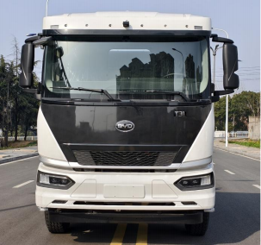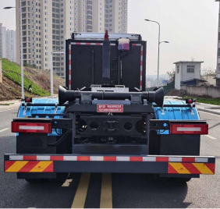
Front Rear
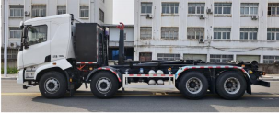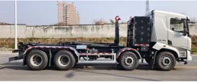
Left Right
二、Functional Overview
The hooklift truck has functions mainly for container loading, container unloading, garbage transfer and discharging, etc.
三、Application
This vehicle can be used for collection and transportation of household waste, kitchen waste, and sorted waste, fast garbage transfer in high-dense population area, as well as integrate with sanitation transfer station: Paired with mobile compactor station, fixed garbage station, it realizes workflow of “container entry station”, “vehicle transport container”.
四、Main Structure and Performance Parameters
The hooklift truck consists of chassis, hooklift mechanism, rear supporting device, hydraulic system, electric system, etc, details as follows:
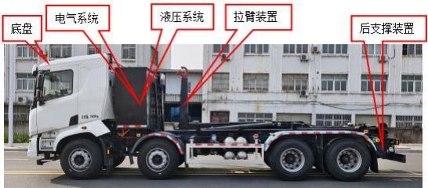
1.Chassis
The vehicle is modified on BYD 1310C2BEVC5 Class II chassis. This chassis boasts powerful power and high load capacity, making it one of the most advanced and reliable pure electric chassis available domestically at present.
The vehicle is equipped with BYD TZ365XSD1 drive motor. Its rated power is 250 kW, and the peak power can reach 370 kW.
2.Hook-lift Device
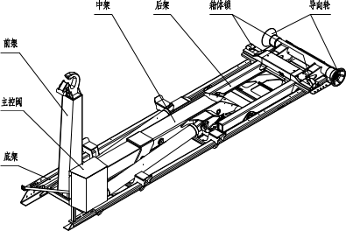
Hook-lift mechanism is equipped on the chassis, and performs function of container loading, container unloading, and discharging.
The container lock in the hooklift mechanism is mainly used to lock the container, restrict its movement to ensure safe transportation, and protect the arm pull device during unloading.
3. Rear Support Device
The rear support device is installed in rear of chassis frame.
When loading or unloading full containers operation, support leg cylinder should be extended completely, to make the rear roller to support ground, preventing vehicle from tipping backward. During normal driving, the support leg cylinder must be retracted, and support roller must be backed.
4. Hydraulic System
The hydraulic system serves as the power and control system that enables all functions of the hook-lift truck.
Hooklift hydraulic system is an open system, oil pump take power from power take-off PTO, to provide hydraulic oil to each circuit cylinder, by change direction of multi-way valve, to control of hydraulic oil flow direction, to regulate each circuit cylinder operation. Hydraulic system consists of main hydraulic cylinder circuit, sliding arm circuit, locking circuit, rear support circuit, and container circuit. The system maximum operation pressure is 30MPa.
Since the tank of the hook lift truck needs to be separated from the vehicle for operation, the carriage circuit is connected to the hydraulic system on the vehicle via quick couplers.
5. Electric System
Hooklift electric system takes power from chassis power supply, by control of switch, electric relay, and sensors, achieving lifting and lowering of the main arm, sliding arm extension and retraction, opening and closing of the container lock, deployment and retraction of rear support, as well as opening and closing container discharging door.
6. Operation Manual
The vehicle adopted electric control mode, standard option include wired control panel(see attached pics), remote controller is an optional.
Operator can handheld the control panel(or remote controller) to operate either seated inside cab seats or stand outside cab.
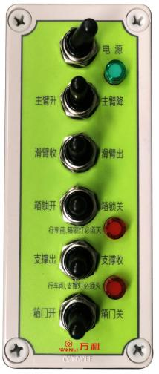
五、Product Technical Parameters
Item |  | Unit | Parameter
Vehicle Parameter | Maximum Total Mass | kg | 31000
Vehicle Parameter | Curb Weight | kg | 15280
Vehicle Parameter | Rated Payload | kg | 15590
Vehicle Parameter | Overall Dimension(L×W×H) | mm | 9830×2550×3320
Vehicle Parameter | Wheel Base | mm | 2000+3400+1400
Vehicle Parameter | Front Overhang/Rear Overhang | mm | 1600/1430
Vehicle Parameter | Approach Angle/Departure Angle | (°) | 14/18
Vehicle Parameter | Minimum Ground Clearance | mm | 250
Operation Performance | Loading Operation Time | s | ≤60
Operation Performance | Uploading Operation Time | s | ≤60
Operation Performance | Discharging Circulation Operation Time | s | ≤110
Operation Performance | Dumping Angle | (°) | 50
Operation Performance | Hook height | mm | 1570
Operation Performance | External Import Width | mm | 1070
Operation Performance | Sliding Arm Horizontal Shift Distance | mm | 1100
Operation Performance | Rated Lifting Capacity | t | 20/22/26
Operation Performance | Upper Structure Hydraulic System Pressure | MPa | 30
Operation Performance | Rear Support Method | / | Rear roller support
Drive Performance | Maximum Speed | km/h | 89
Drive Performance | Maximum Slope Angle | % | 30
Drive Performance | Minimum Turning Diameter | m | 24
Chassis Parameter | Chassis Model, Type, Manufacturer | BYD1310C2BEVC5  Class II Chassis  BYD Auto Industry Co Ltd
Chassis Parameter | Drive motor model, type and manufacturer | TZ365XSD1 Permanent Magnet Synchronous Motor  BYD Auto Industry Co Ltd
Chassis Parameter | Rated Power/Speed/Torque  （kW/r/min/N.m） | 250/1705/1400
Chassis Parameter | Peak Power/Speed/Torque  （kW/r/min/N.m） | 370/3300/2500
Chassis Parameter | Drive Motor Controller Model, Manufacturer | KTZ64X44S6AB  BYD Auto Industry Co Ltd
Chassis Parameter | Battery Model | B32/B22 Lithium Iron Phosphate Battery
Chassis Parameter | Battery Storage (kWh) | 348.47
Chassis Parameter | Voltage (V) | 524.8
Chassis Parameter | Driving Range (km) | 330

六、Product advantage
1. Outstanding Performance
The arm pull structural parts are made of high-strength steel, and high-strength precision castings are adopted for key positions (the positions shown in the following four figures) to enhance safety and extend service life.
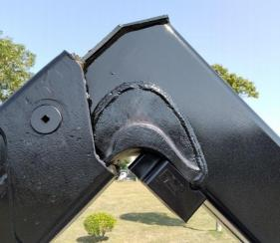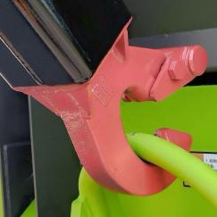
Right angle of the front frame Hook ring area
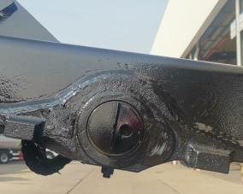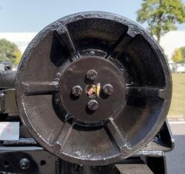
Rear frame bearing bottom Guide roller

2. Superior Quality
High-standard accessory configuration. Key hydraulic and electrical components including hydraulic oil pumps, main control valves, hydraulic locks, balancing valves and proximity switches are internationally renowned brands with excellent quality and high reliability.
3. Safe and Reliable
Electro-hydraulic interlock logic control, hooklift upper structure is fitted with multiple electro-hydraulic interlock logic control devices for enhance safety.
During the unloading operation, the cargo box can only be lifted for unloading after the box lock and tipper lock are engaged.
Container lock and front frame shall remain inactive throughout the discharging process.
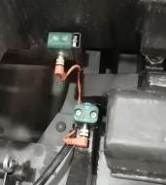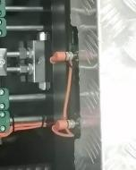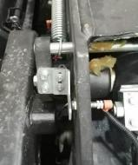
Buffer and Descending Device. A tank buffer and descending device is installed in the hydraulic system. When the tank descends to a certain angle, the sensor triggers an electrical signal. The circuit controls the buffer valve in the hydraulic system, enabling the tank to lower gently onto the vehicle and avoid rigid impact.
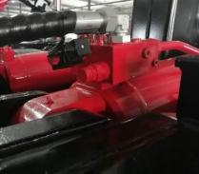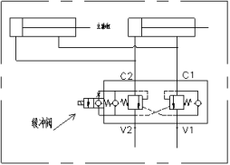
Safety support. The vehicle is equipped with safety support device, it must deployed in case of lifting the hooklift for repairing, to protect the safety of maintenance personal.
Buzzer is fitted on the vehicle. It emits voice alarm during hooklift upper structure operation, to alert personal in the working area, and guarantee the personal and equipment safety.
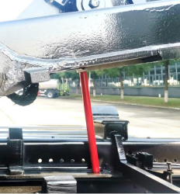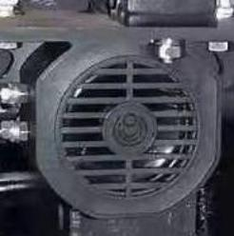
Safety Support Buzzer
Rear supporting device. The rear roller support device is installed at the rear of vehicle, to extend rear roller on ground before hooklift lifting full loaded container, to prevent vehicles from tipping backward, to ensure safe and reliable operation.
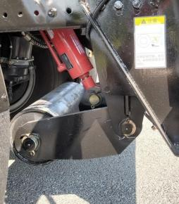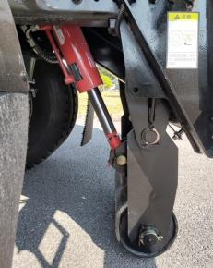
Retract Roller Stretch Roller
- High Maintainability
It is convenient to maintenance. The hooklift can be lifted during repairing, to provide ample working space. Hydraulic pipe and electrical wiring are neatly arranged, to make it easy for troubleshooting and component replacement.
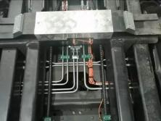
七、Operation Function
Loading container, the hooklift lifts container from ground (or platform) onto vehicles.
Unloading Container. Hooklift lowers the container from vehicle to ground(or platform)
Transfer. The hooklift travels with the container mounted.
Discharging. The hooklift lifts the container, and dumps the garbage.
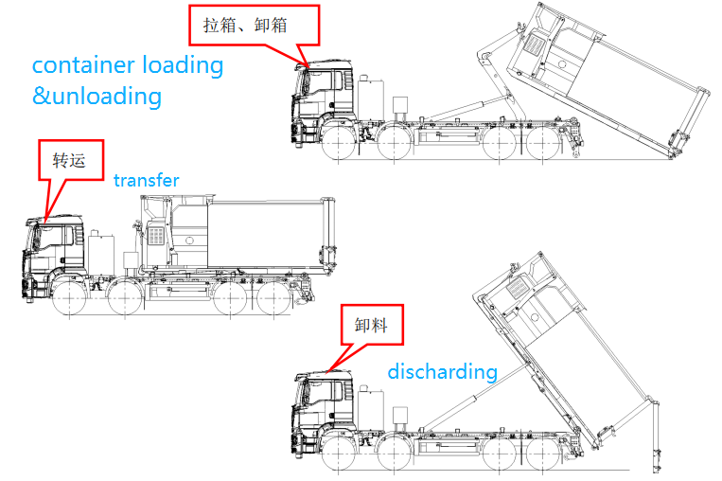
Hooklift lock box, open the door
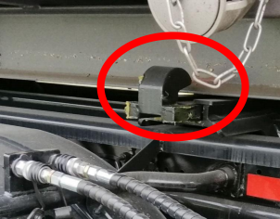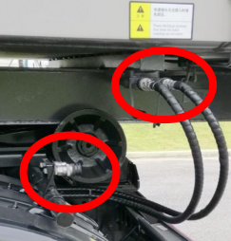
图 1 图 2
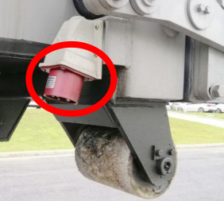
图 3

As shown in Figure 1, measure the locking area on the container guide rail to ensure the locking hook of the hooklift can lock the container securely (B1＜B＜B2).
As shown in Figure 2, if the container door is hydraulically driven, photograph and record the position and model of hydraulic quick connectors fitted on the container.
As shown in Figure 3, if the container door is electrically driven, photograph and record the position and model of electrical plugs fitted on the container.
Photographic records shall also be taken for containers with manually operated doors.

